

Lewis University, ABQ Campus

**Title**: Building eco-friendly housing projects using recycled and upcycled materials

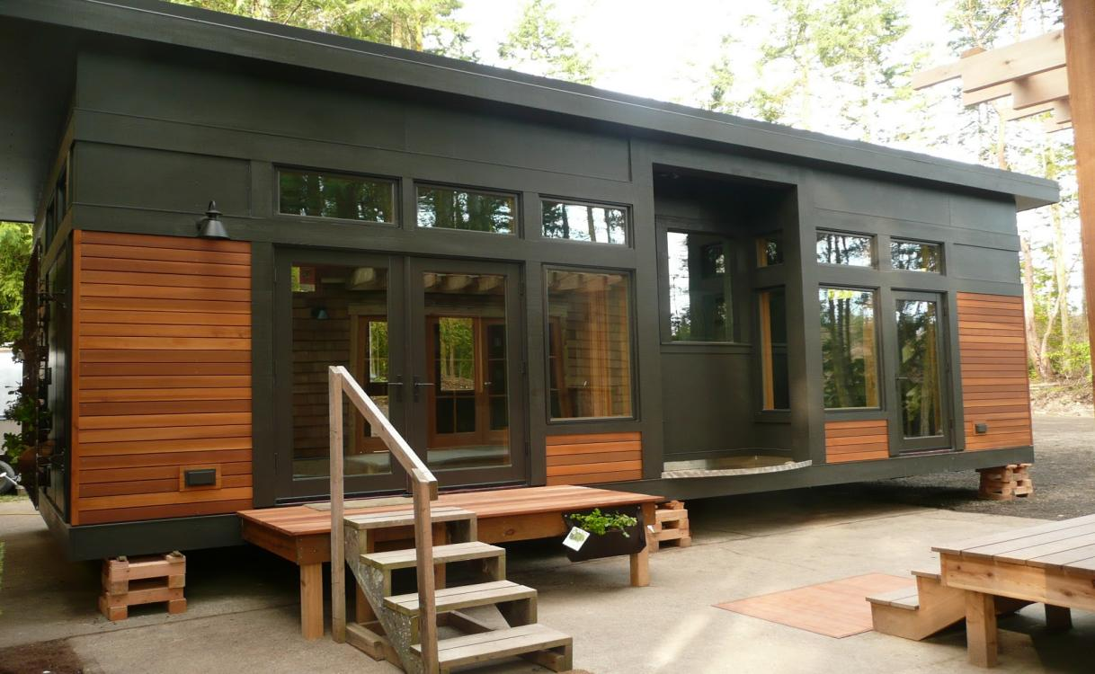

**Github Url:** <https://github.com/Vikasreddy-98/vikasreddy98/tree/Eco-friendly-homes>

**SQL Environment:** Windows.

|  |  |
| --- | --- |
| **Course code** | FA23-CPSC-50900-005 |
| **Course Title** | Database Systems |
| **Term** | Fall 2023 |
| **Professor** | Mr. Matthew Clavelli |
| **Submitted By** | Vikas Reddy Dopathi |

**Part-1:**

Briefly describe your business, estimated company size in terms of people and locations, and your supply chain. Your supply chain consists of:

1. What your raw materials are (need at least 3)

2. Where you get your materials from (two sources per material)

3. Where your primary office is, and how many cities do you operate in?

**Business:**Eco-Friendly Homes.Inc.

**Business Description:**

Eco-Friendly Homes is an environmentally conscious housing project company that specializes in designing and constructing sustainable, eco-friendly residential properties.

Our Mission is to create homes that not only provide comfort and luxury but also prioritize ecological responsibility and energy efficiency.

**Company Size:** Eco-Friendly Homes employs a diverse team of approximately 100 professionals,including architects,engineers, eco-design experts,and construction personnel

**Supply Chain:**

**Raw Materials:**

**a. Recycled Building Materials**: Sourced from reclaimed construction materials to reduce waste.

**b. Sustainable Timber**: Sustainably harvested timber from certified forests.

**c. Energy-Efficient Insulation**: High-performance insulation materials for reduced energy consumption.

**Material Sources**:

**a. Recycled Building Materials:**

Collaboration with Demolition Companies: Partnership with firms specializing in deconstruction and material salvage from Germany and United States.

**b. Sustainable Timber:**

Certified Forestry Operations: Partnering with eco-conscious forestry companies that adhere to sustainable practices from Japan and India.

**c. Energy-Efficient Insulation:**

Green Building Suppliers: Procuring advanced insulation materials from suppliers focused on energy-efficient solutions from Dubai and Kuwait.

**Primary Office and Locations:**

Eco-Friendly Homes is headquartered in an sustainable office building, with multiple offices in urban centers and regions known for Eco-conscious living. Our construction projects are situated in various locations, tailored to client needs, from urban settings to remote nature retreats.

**Part-2:   
Draw.io:** <https://github.com/Vikasreddy-98/vikasreddy98/blob/Eco-friendly-homes/vikas.drawio>

**Architecture Diagram**

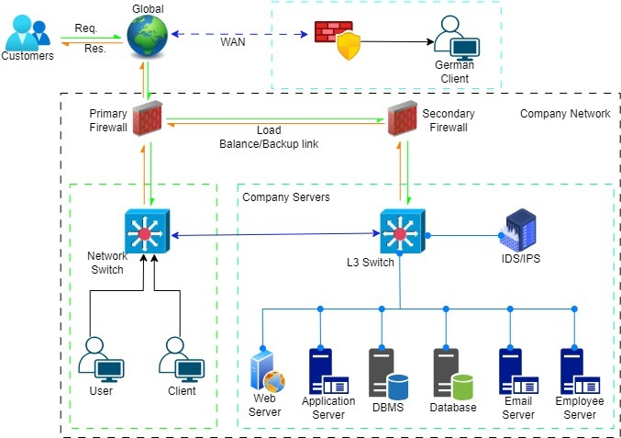

**Part 2: Data Entities, Attributes, and Files**

**Entities:**

1. **Customer:**

* **Description:** An individual or organization that transacts with a business or service by using or purchasing its goods or services is considered a customer. It includes details like Name,Email,Phone,Address.

|  |  |
| --- | --- |
| **Customer** | **Datatype** |
| Customer Id | INTEGER |
| Name | VARCHAR(50) |
| Email | VARCHAR(100) |
| Phone | VARCHAR(20) |
| Address | VARCHAR(255) |

1. **Employee:**

* **Description:** An employee is an individual who works for an organization, company, or business. It includes details like Employee ID,Job title,Salary,Email,Hire date.

|  |  |
| --- | --- |
| Employee | **Datatype** |
| Employee ID | INTEGER |
| Name | VARCHAR(50) |
| Email | VARCHAR(100) |
| HireDate | DATE |
| Position | VARCHAR(50) |

1. **Product:**

* **Description:**A product is anything created, manufactured, or sold to customers, whether it be digital or tangible.It includes Product ID,Name,Price,Quantity.

|  |  |
| --- | --- |
| **Product** | **Datatypes** |
| ProductID | INTEGER |
| Name | VARCHAR(50) |
| Description | TEXT |
| Price | DECIMAL(10, 2) |
| StockQuantity | INTEGER |

1. **Order:**

* **Description:**An order is when a customer asks to buy something, and it includes what they want, the date, and how much it costs

|  |  |
| --- | --- |
| **Order** | **Datatypes** |
| OrderID | INTEGER |
| OrderDate | DATE |
| TotalAmount | (DECIMAL(10, 2)) |

**5.Location:**

* **Description:**The "Location" entity represents physical places or geographic points that can be important for identifying customer addresses, tracking inventory locations, or managing property information. Locations can include home addresses, office addresses, warehouse coordinates.

|  |  |
| --- | --- |
| **Location** | **Datatype** |
| Location Name | VARCHAR(100) |
| Address | VARCHAR(255) |
| Latitude | DECIMAL(10,6) |
| Longitude | DECIMAL(10,6) |
| Type ( Home, Office, Warehouse) | VARCHAR(50) |

**Github URL Link** :https://github.com/Vikasreddy-98/vikasreddy98/blob/main/CSV's%20XML%20files.zip